Depression
Name
Institution
Date

Depression
Topic Description
- Depression refers to mood disorders that makes people sad and lose interest persistently.
- Depression affects people’s feelings, behaviors, thinking, and actions, and may lead to various physical as well as emotional issues (Langer et al., 2019).
- Depression is caused by factors such as biological differences, hormones, inherited traits, and brain chemistry.
- The factors that increase the risk of depression include trauma events, personality characters like low self-esteem, a history of mental health issues like anxiety disorder, family history of depression, and specific medications like the ones used for treating high blood pressure (Langer et al., 2019).
- If not treated, depression may result in complications like obesity that can cause heart attack, social isolation, suicidal attempts or thoughts, social phobia, anxiety, drug abuse, and premature death.
- I perceive depression to be an important topic to educate my classmates because depression cases have been skyrocketing, and thus need to be addressed.
Did you know that around 17.3 million Americans aged 18 and above have at least one key depressive disorder (National Institute of Mental Health, 2019)?
Pathophysiology
- Depression is a mood disorder that makes people sad and loses interest persistently.
- Depression affects people's thinking and behaviors negatively and may result in emotional as well as physical issues.
- When people are depressed, the hippocampus produces a hormone called cortisol. Higher and persistent production of cortisol slows the growth of neurons, and the hippocampus shrinks, causing memory problems (Kraus et al., 2017).
- Higher levels of cortisol also cause enlargement of the amygdala, which is the brain part responsible for emotional responses. The enlargement of the amygdala, in turn, results in disturbed sleep patterns and changes in activity levels, which are symptoms of depression.
- Depression not only affects the brain but also causes other body changes like loss of appetite and chronic pain.
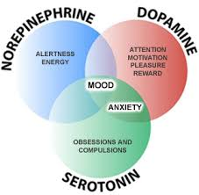
Signs and Symptoms
- Frequent thoughts of committing or attempting suicide
- Lack of interest in activities like sex and sports
- Sleep disturbances like insomnia
- Memory problems of difficulties in concentration
- Feelings of hopelessness, tiredness, and emptiness
- Irritation, outburst, and frustration
- Anxiety and restlessness
- Low self-esteem or feeling of worthlessness
- Lack of energy to complete even small tasks (Langer et al., 2019)
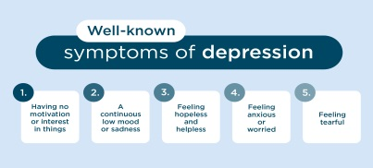
Treatment
- The most effective and common treatment interventions for depression are the use of medications and psychotherapy.
Medications
- Selective serotonin reuptake inhibitors (SSRIs) – examples are fluoxetine and paroxetine, and they are generally preferred because they are safer and result in fewer side effects. Specifically, these drugs increase serotonin levels in the brain (Ghandour et al., 2019).
- Serotonin-norepinephrine reuptake inhibitors (SNRIs) - include venlafaxine and duloxetine. These drugs relieve symptoms like depression and irritation.
- Atypical antidepressants- include mirtazapine and bupropion. They relieve depression by affecting neurotransmitters that facilitate communication between brain cells.
- Tricyclic antidepressants- examples are doxepin and trimipramine, and they are effective in preventing pain and migraines associated with depression.
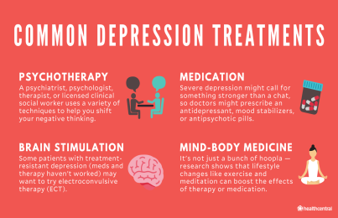
Psychotherapy
- Psychotherapy involves treating depression my communication with a mental health professional.
- Psychotherapy interventions that can be effective in the treatment of depression are cognitive behavioral therapy and interpersonal therapy.
- Psychotherapy helps in;
- Identifying negative beliefs and behaviors
- Identifying factors that contribute to depression
- Developing positive socialization with other people
- Finding better coping interventions
- Developing resilience to stress (Weitz et al., 2018)
Depression is not a condition you can only treat on your own. Seek professional treatment.
Patient Education
- Increase socialization by reaching out to friends and families
- Enhance resilience and boost self-esteem
- Seek early treatment to prevent worsening of symptoms
- Consider long-term treatment to prevent symptoms relapse
- Manage stress effectively
- Avoid using alcohol and recreational drugs
- Get educated about depression
- Do not despise warning signs
- Adhere to treatment plans (Lyle-Edrosolo & Waxman, 2016).

References
Ghandour, R. M., Sherman, L. J., Vladutiu, C. J., Ali, M. M., Lynch, S. E., Bitsko, R. H., & Blumberg, S. J. (2019). Prevalence and treatment of depression, anxiety, and conduct problems in US children. The Journal of pediatrics, 206, 256-267.
Kraus, C., Castrén, E., Kasper, S., & Lanzenberger, R. (2017). Serotonin and neuroplasticity–links between molecular, functional and structural pathophysiology in depression. Neuroscience & Biobehavioral Reviews, 77, 317-326.
Langer, J. K., Tonge, N. A., Piccirillo, M., Rodebaugh, T. L., Thompson, R. J., & Gotlib, I. H. (2019). Symptoms of social anxiety disorder and major depressive disorder: A network perspective. Journal of affective disorders, 243, 531-538.
Lyle-Edrosolo, G., & Waxman, K. T. (2016). Aligning healthcare safety and quality competencies: quality and safety education for nurses (QSEN), The Joint Commission, and American Nurses Credentialing Center (ANCC) magnet® standards crosswalk. Nurse Leader, 14(1), 70-75.
National Institute of Mental Health. (2019). Major Depression. Retrieved from https://www.nimh.nih.gov/health/statistics/major-depression.shtml
Weitz, E., Kleiboer, A., van Straten, A., & Cuijpers, P. (2018). The effects of psychotherapy for depression on anxiety symptoms: a meta-analysis. Psychological Medicine, 48(13), 2140-2152.

